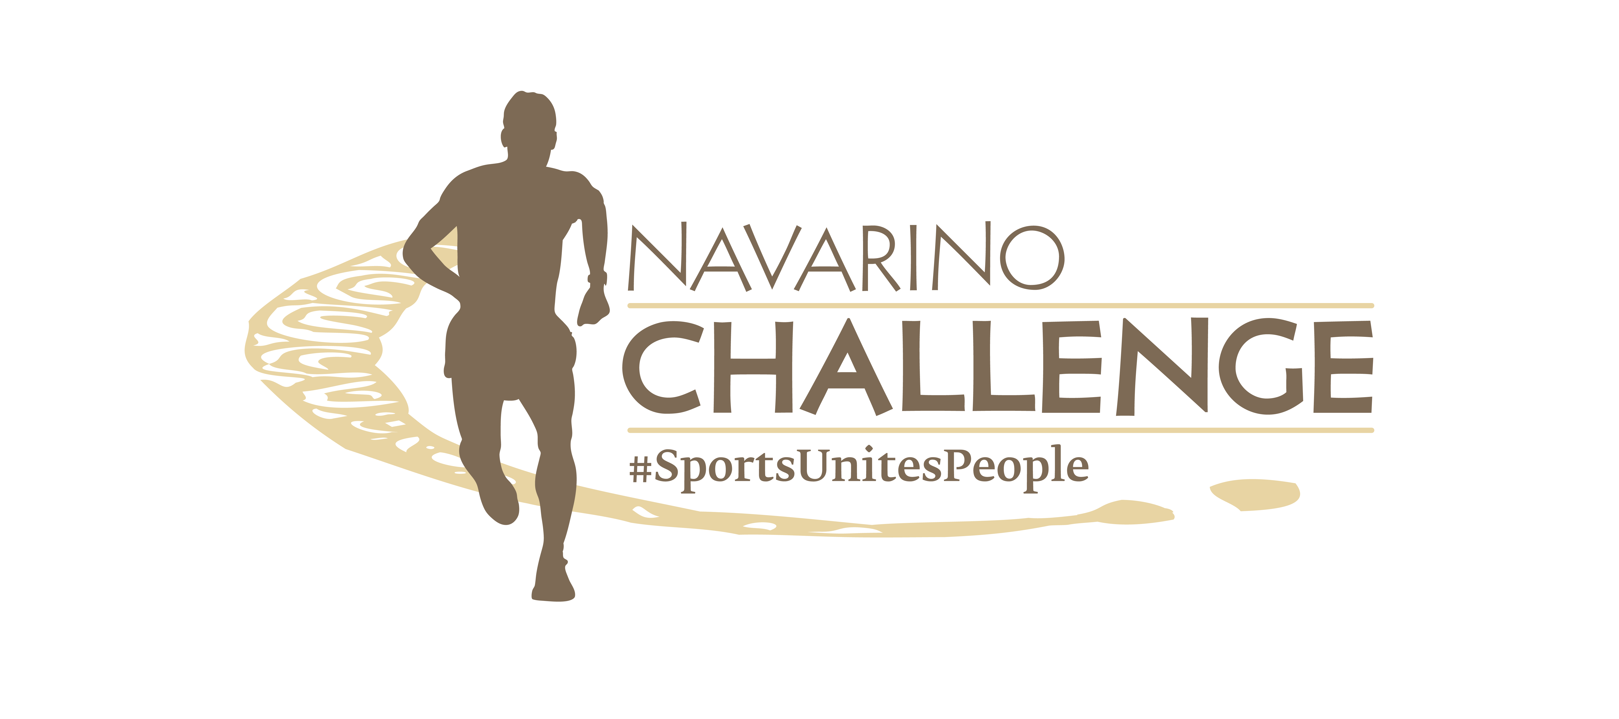

PRESS RELEASE

Navarino Challenge 2024 Schedule

More than 60 activities for everyone in 3 days

Athens, October 18, 2024 – The greatest celebration of sports tourism and wellness, Navarino Challenge, is approaching and is set to welcome amateur and professional athletes of all ages and abilities for its 12th year. Under the message “Sports Unites People”
the event will host over 60 activities from October 18-20 at Costa Navarino, The Westin Resort Costa Navarino and W Costa Navarino and the Municipality of Pylos-Nestor.

The historic Navarino Bay and Sphacteria Island, Gialova Lagoon, and Voidokilia Beach, part of the Natura 2000 network, along with Niokastro, Paliokastro, Pylos, Chora, and Koroni, will once again be showcased. Their breathtaking scenery will be shared worldwide through the diverse activities presented in the Navarino Challenge 2024 schedule.
For the full schedule: https://www.navarinochallenge.com/schedule-2024

Top sports personalities such as Olympic gold medalist Lefteris Petrounias, three-time Olympian Vasiliki Millousi, Olympic and European champion Periklis Iakovakis, European champions Kostas Katsouranis and Dimitris Papanikolaou, Olympian and EuroBasket MVP Evina Maltsi, volleyball legend Michalis Triantafyllidis, EuroLeague champion Joe Arlauckas, tennis champion Giorgos Lazaridis, champion Georgia Kaltsi, and athlete Giorgos Chatziefstathiou will be at Costa Navarino, introducing participants to the secrets of each sport.

Enjoy unique sports activities again this year, including:
- Wheelchair Basketball Exhibition Game powered by Vikos, with wheelchair athletes and the National Team, featuring Georgia Kaltsi
- 4on4 Basketball Tournament powered by Trace 'n Chase
- Tennis Exhibition Game powered by Miele with tennis champion Giorgos Lazaridis
- High-Intensity Training powered by Squatwolf for all ages with Dimitris Moros and FitnessArt
- Tennis Induction (ages 6-9 & 10-13) powered by Miele, supported by Mouratoglou Tennis Center Costa Navarino
- Baby Swimming powered by Vlacha for children under 3, supported by Red Swim Academy & Swim O’ Clock
- Skateboarding supported by Free Movement Skateboarding
- Pickleball Induction & Game Play with Michalis Triantafyllidis, supported by Mouratoglou Tennis Center
- Spinning Challenge powered by Squatwolf, hosted by Dimitris Moros and FitnessArt
- F45 Barrio Salamanca meets FitnessArt at W Costa Navarino
- Kayaking around Sphacteria Island powered by YAMAHA with support from Moraitis Watersports
- Men’s Round Robin Tournament powered by Miele
- Basketball Lessons for Kids (ages 5-16) powered by Knorr with Evina Maltsi and Joe Arlauckas
- Group Cycling for all ages powered by Vikos, hosted by Dimitris Moros and FitnessArt
- Aqua Yoga with Valia Moralis, supported by Red Swim Academy
- Ladies Morning Tennis powered by Miele at Mouratoglou Tennis Center
- Knockout Challenge powered by Trace 'n Chase
- Beachathlon powered by Korres with Olympic champion Periklis Iakovakis
- Padel Tournament powered by Lacoste at Mouratoglou Tennis Center
- Golf Lessons powered by Miele, supported by Navarino Golf Academy
- Cycling at Voidokilia Beach powered by YAMAHA
- Corrective Exercise Session led by Joint Athens, teaching body movement and pain relief techniques.

Side Events:
- Traditional Thessaloniki Koulouri Making with Chef Alexandros Syngiridis of Miele
- 2km Walk powered by Novo Nordisk from the home of Olympian Kostis Tsiklitiras to Niokastro, ending with a sunset at Tsichli Baba
- Documentary Screening: "The Secrets of Olympus" with Michalis Stylas from The North Face
- Seminar on Childhood, Adolescent, and Adult Obesity powered by Novo Nordisk
- Pasta Corner with Miele Chef Alexandros Syngkiridis
- Traditional Messinian Cooking Experience powered by Miele

The three-day event will conclude on Sunday, October 20, in the Municipality of Pylos-Nestor with:
- The reenactment of the Battle of Navarino, known as the “Navarinia” in Pylos.

Run at Voidokilia Beach
Participants can take part in running routes of 21.1km powered by The North Face, 10km by the sea, 5km powered by Miele among olive trees, and a 1km run for children aged 0-14. There will also be a 1km Run for All – Everyone Unique, Everyone Equal powered by the MOTODYNAMICS Group.

Book Your Stay
Enjoy a weekend filled with outdoor activities. For accommodation packages at W Costa Navarino and The Westin Resort Costa Navarino contact booking(at)navarinochallenge.com or Vita N Travel at +30 210 3249070.

The top insurance group, wedo.insure, with over 50 years of experience and growth, is supporting the Navarino Challenge for the first time as the Official Insurance Partner of the event. With reliability, innovation, and a commitment to transparency, wedo.insure seeks the best solutions for you. More information: https://wedo.insure

Plan your transfer to Messinia with the assistance of Messinia Transfer, owned by Mr. Lappas (+30 6947208454). Enjoy the comfort and quality services it offers. Make your reservation now for any transport you need during the event and get a 10% discount on your transfers. More information: www.messiniataxi.gr

Platinum Sponsor: Miele
Gold Sponsor: MOTODYNAMICS Group
Official Hospitality Sponsors: Costa Navarino, W Costa Navarino, The Westin Resort Costa Navarino
Silver Sponsors: Knorr, The North Face
Strategic Healthcare Sponsor: Novo Nordisk
Official Water: Vikos Natural Mineral Water
Official Helicopter Partner: hoper
Official Sports Supplier: Luanvi
Bronze Sponsors: KORRES, Trace 'n Chase, Pilia Express
Premium Mobility Partner: SIXT, member of the MOTODYNAMICS Group
Authentic Flavor Partner: Navarino Icons
Navarino Challenge Partners: Messinian Nest, Pylos-Nestor Municipality, Bombay Sapphire, Poseidonia Restaurant, Karalis Beach Hotel, Karalis City Hotel & Spa
Official Optics Partner: Kois Optics
Official Insurance Partner: wedo.insure
Supporters: Alpha Estate, Vlaha, Messinian Spa, Elite Boats, Zoe Resort, Silk Gonos
Premium TV Partner: SKAI
Premium Media Partner: Liquid Media
Medical Partner: Athens Medical Group
Sustainability Partner: π³ = Plastic Pollution Prevention
Educational Partner: Athens University of Economics and Business
Official Basketball: Wilson
Assisted by: Vita N Travel, Pylos Tourist Development Association, Lacoste, Rania’s Flower, Messinia Transfer, Humanity Greece
Athletic Partners: Angelic Yoga Arts, F45 Barrio Salamanca, Falcons Football Academy, FitnessArt, Free Movement Skateboarding, Gymnastics Stars, Joint Athens, Moraitis Watersports, Mouratoglou Tennis Center Costa Navarino, Navarino Golf Academy, Navarino Outdoors, Pilates by Mandy, Red Swim Academy, Swim O’ Clock, Triantafyllidis Beach Arena

Navarino Challenge is held under the auspices of the Ministry of Tourism, the Greek National Tourism Organization, and the Peloponnese Region. All running events are co-organized with the Messiniakos Gymnastics Club and SEGAS Peloponnese. The organization and sports production is managed by ActiveMedia Group.

#navarinochallenge #costanavarino #sportsunitespeople #eatwell #runwell #livewell

Website: www.navarinochallenge.com
Facebook: www.facebook.com/Navarinochallenge
Instagram: http://instagram.com/navarinochallenge
Twitter: https://twitter.com/NavarinoC
YouTube: http://www.youtube.com/user/NavarinoChallenge
TikTok: https://www.tiktok.com/@navarino_challenge

