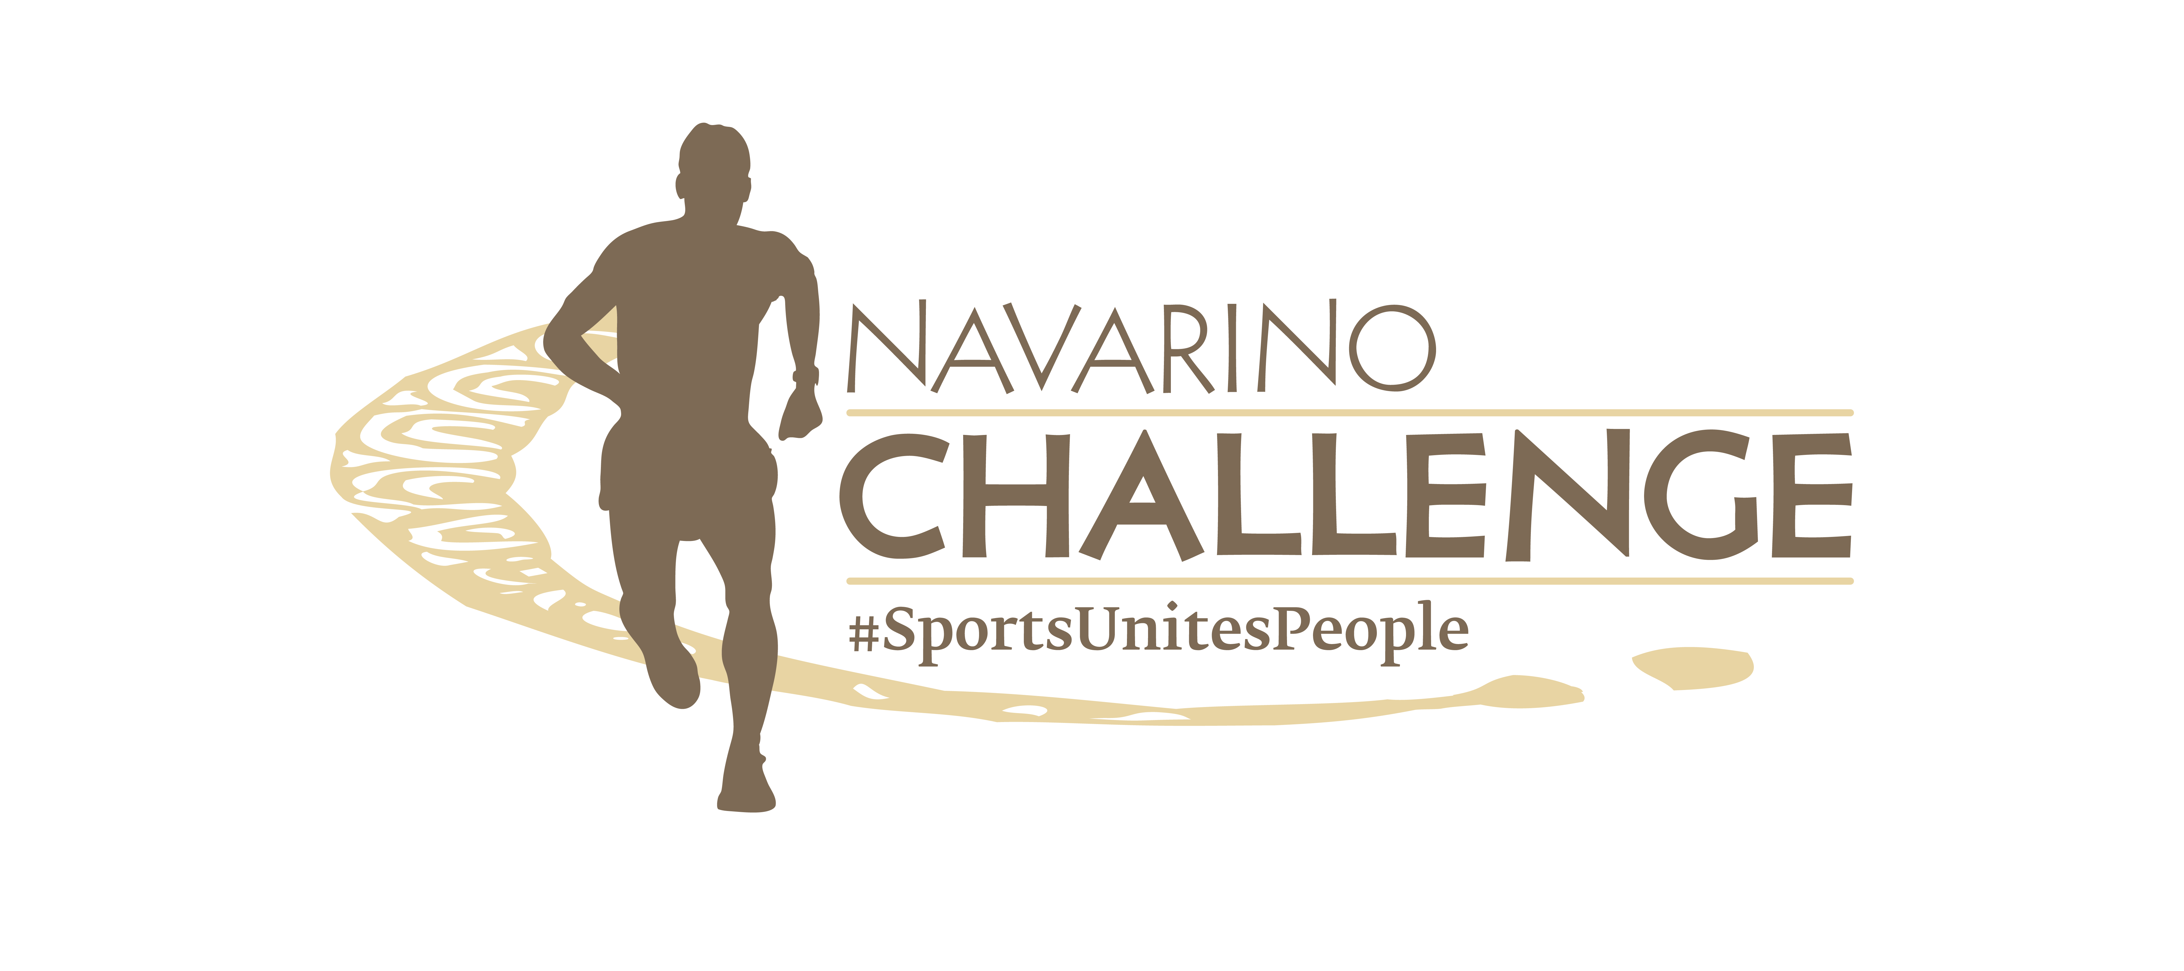

PRESS RELEASE

Unique Outdoor Activities for Everyone
at Navarino Challenge 2024

Athens, July 17, 2024 – The sports tourism and wellness event Navarino Challenge updates its schedule annually with new activities for people of all ages and abilities. With the message “sports unites people” Navarino Challenge will be held for the 12th year on October 18-20, 2024, at Costa Navarino and Pylos. More than 55 activities will be hosted at two of the destination’s four hotels, W Costa Navarino and The Westin Resort Costa Navarino.

The North Face Athletes to Run the Scenic Routes of Navarino Challenge
This year, the team of athletes from The North Face is expected to have a dynamic presence, competing in the top Half Marathon powered by The North Face with athletes Giorgos Dimoulas, Alexandros Tzoumakas, and Nikoletta Tzavara, discovering the exciting route that crosses Voidokilia and combines dirt, sand, and asphalt with the message “Never Stop Exploring”.

Register for the Running Activities
Participants can join the 21.1km route powered by The North Face, 10km, 5km powered by Miele, and 1km races right away. The children’s race is free of charge. Register through the special form available at the following link.

High-Intensity Training & CrossFit with Dimitris Moros
In collaboration with the top physical education professor Dimitris Moros and FitnessArt, Navarino Challenge will also conduct CrossFit activities powered by Squatwolf and high-intensity training powered by Squatwolf, ensuring the muscular strengthening of the participants. Squatwolf, the Premium Gymwear Brand from DUBAI, which came to Greece exclusively by SportAdore is participating for the first time in a Greek sports event, presenting technical gym clothes that elevate training to another level.

Water Activities with Moraitis Watersports
The beloved water sports that made a dynamic debut last year will once again feature the name and signature of Moraitis Watersports. Sea and adrenaline lovers can choose from a wide variety of activities in the historic Bay of Navarino through three different vouchers. The “Watersports Voucher 1” includes Windsurf and Kayak Tour. The “Watersports Voucher 2” includes Wakeboard, Waterski, Wakesurf, and Wingfoil, with 10% of the proceeds going to the charity action “Sharing Is Caring” and to 12 NGOs. Finally, the “Watersports Voucher 3” includes e-Foil, Kitesurf, and Catamaran activities. Participation in the activities requires booking accommodation at Costa Navarino through Navarino Challenge. Register through the special form available at the following link.

Beach Volleyball with Michalis Triantafyllidis
In collaboration with the former international volleyball player and record-holder for national team appearances, Michalis Triantafyllidis, and Triantafyllidis Beach Arena, the King of the Court Beach Volleyball Tournaments powered by Bacardi will be held again this year. In anticipation of the NAVARINO CHALLENGE King of the Court event, which will be held at the Dunes Beach at Costa Navarino, Triantafyllidis Beach Arena is organizing a series of tournaments this summer: the BEACH ARENA CHALLENGE King of the Court. The top 2 champions from the entire series, will win free participation in the exciting NAVARINO CHALLENGE King of the Court and complimentary accommodation in Pylos, while there will be a draw for 5 free entries in the NAVARINO CHALLENGE King of the Court. For more information: www.beacharena.gr

Book your accommodation package now
Enjoy a weekend full of outdoor sports activities for all ages. Book now the complete sports activities package and experience a unique sports and cultural event. For more information on accommodation packages at W Costa Navarino and The Westin Resort Costa Navarino please email booking(at)navarinochallenge.com or call Vita N Travel at +30 210 3249070. Check the accommodation packages here.

Miele is the Platinum Sponsor.
MOTODYNAMICS Group is the Gold Sponsor.
Costa Navarino, W Costa Navarino, and The Westin Resort Costa Navarino are the Official Hospitality Sponsors.
Knorr, and The North Face are the Silver Sponsors.
Vikos Natural Mineral Water is the Official Water.
Luanvi is the Official Sports Supplier.
KORRES, Trace ‘n Chase, and Pilia Express are the Bronze Sponsors.
SIXT, a member of the MOTODYNAMICS Group is the event’s Premium Mobility Partner.
Navarino Icons is the event’s Authentic Flavor Partner.
Messinian Nest, Municipality of Pylos-Nestor, Bacardi, Poseidonia Restaurant, Karalis Beach Hotel, and Karalis City Hotel & Spa are the event’s Partners.
Kois Optics are the Official Optics Partner.
Vlaha, Phee, Messinian Spa, and Zoe Resort are the Supporters.
SKAI is the Premium TV Partner.
Liquid Media is the Premium Media Partner.
Athens Medical Group is the Medical Partner.
p³ = Plastic Pollution Prevention is the Sustainability Partner.
Athens University of Economics and Business is the event’s Educational Partner.
Angelic Yoga Arts, Falcons Football Academy, FitnessArt, Gymnastics Stars, Moraitis Watersports, Mouratoglou Tennis Center Costa Navarino, Navarino Golf Academy, Navarino Outdoors, Pilates by Mandy, Red Swim Academy, Swim O’ Clock, Triantafyllidis Beach Arena are the Athletic Partners.
The event is Assisted by Vita N Travel, and Pylos Association of Enterprises for Tourism Development.

Navarino Challenge will be held under the auspices of the Ministry of Tourism, the Greek National Tourism Organization, and the Region of Peloponnese.
The event is organized by ActiveMedia Group, which is also responsible for the event’s Sports Production.

More information about this year’s activities and schedule will be announced in the coming weeks.

#navarinochallenge #costanavarino #sportsunitespeople #eatwell #runwell #livewell

Website: www.navarinochallenge.com
Facebook: www.facebook.com/Navarinochallenge
Instagram: http://instagram.com/navarinochallenge
Twitter: https://twitter.com/NavarinoC
YouTube: http://www.youtube.com/user/NavarinoChallenge
TikTok: https://www.tiktok.com/@navarino_challenge

