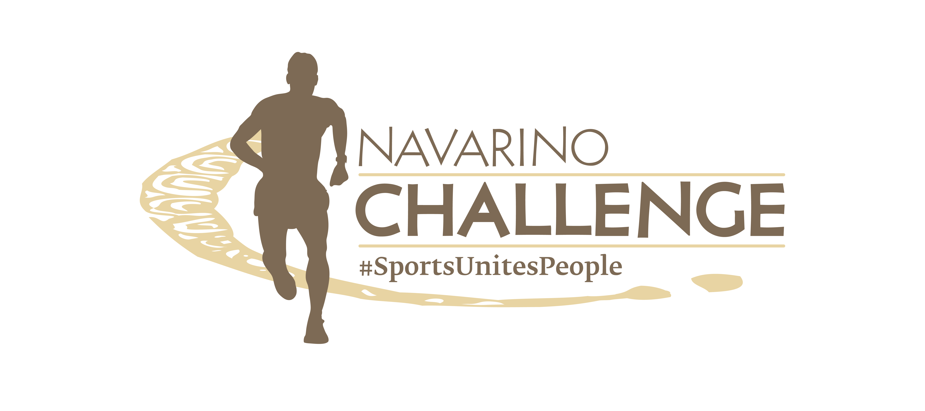

PRESS RELEASE

Wellness, Longevity, Gastronomy
at Navarino Challenge 2024

The multi-sport event
presented its activities for this year

Athens, June 17, 2024 – The sports tourism and wellness event Navarino Challenge returns for its 12th year, on October 18-20, 2024, at Costa Navarino and Pylos. With the global message “sports unites people” the event officially presented more than 55 activities included in this year’s schedule, which will be held at two of the four destination’s hotels, W Costa Navarino and The Westin Resort Costa Navarino.

The press conference of Navarino Challenge was hosted at the Stavros Niarchos Foundation Cultural Center, in the presence of the Secretary General of Sports, Mr. George Mavrotas, the Mayor of Pylos-Nestor, Mr. Panagiotis Karvelas, the Deputy Regional Governor of Tourism of Peloponnese, Mr. Athanasios Michelogonas, ambassadors such as Constantine “Dean” Karnazes, Kostas Katsouranis, Michalis Triantafyllidis, Georgia Kaltsi, George Lazaridis, event sponsors, journalists, and media representatives. The press conference was presented by the reputable journalist, Stefanos Avramidis.

The event was greeted via video by the Minister of Tourism, Ms. Olga Kefalogianni, who among other things said: “Navarino Challenge is an institution that promotes sports, health, and culture with numerous activities set against the beautiful backdrop of Messinia and the facilities of Costa Navarino, a pioneering destination globally, which guarantees an unforgettable experience for spectators and participants. The event brings together elements that can contribute to gentle and sustainable tourism development. I would like to congratulate the organizers who for over a decade have worked to highlight the Navarino Challenge as an event of international appeal”.

The Secretary General of Sports, Mr. George Mavrotas, stated: “The development of sports in our country is a matter of public interest for four main reasons: (a) the promotion of citizens’ health, (b) the cultivation of values, especially for the younger generations, (c) the country’s international image, (d) economic development. All four reasons are combined in the Navarino Challenge, highlighting the very rich potential our country has in sports tourism and making it one of our country’s ‘flagships’ in this field. I want to express my congratulations for the continuously increasing appeal and success of the Navarino Challenge for over 10 years. Good luck with this year’s event”.

The Mayor of Pylos-Nestor, Mr. Panagiotis Karvelas, said: “It is our honor and pleasure to participate in the Navarino Challenge once again. The Municipality of Pylos-Nestor has supported this effort from the first year (2013) and together with the organizers we have managed to develop sports tourism in our Municipality. This year, Navarino Challenge coincides with the great celebration of the Navarinia, honoring the history of all the nations that participated and the people who became immortal by laying the foundation for the establishment of the modern Greek state. We look forward to many activities this year in the Municipality of Pylos-Nestor”.

Navarino Challenge Under the Auspices of the Peloponnese Region
The Deputy Regional Governor of Tourism of Peloponnese, Mr. Athanasios Michelogonas, mentioned among other things: “For us, Navarino Challenge is a model that showcases how to organize a successful project in the Peloponnese. Through this event, not only the value of sports is highlighted, but also the touristic dynamics of our region. This institution significantly contributes to the promotion of the Peloponnese as a destination, attracting visitors from various parts of the world and reinforcing the local economy. Sports unites people, promotes health, and creates strong bonds between communities. Navarino Challenge is a living example of these values”.

Then, the Ambassador of Greek Tourism and Ultramarathoner Constantine “Dean” Karnazes highlighted: “I have traveled to sporting events across the globe and Navarino Challenge is a world leader in the number of sports and activities and the quality of organization. I am honored to be part of this great event which showcases the very best Greece has to offer in sports, gastronomy, hospitality, and culture”.

The Chief Executive Officer of ActiveMedia Group, Mr. Akis Tsolis, mentioned among other things in his presentation: “In 2019, we were talking about well-being, while today the new trend or more correctly the big challenge is longevity, how we will live longer and better. With the global message ‘sports unites people’ we look forward to seeing you at Costa Navarino and Pylos for the 12th Navarino Challenge with the most activities ever held”.

Gastronomy & Sports Tourism at the Center
The Managing Director of Miele, Mr. Thanos Kyriazis, said: “Miele Hellas, as a platinum sponsor this year, supports for the 3rd consecutive year the top Wellness and Sports Tourism event in Europe. A truly unique event whose values align with those of Miele. Values such as integrity, noble competition, inclusion of diversity, social contribution, and the passion for continuous evolution and quality creation! We celebrate today this great meeting of values and commit to continuing to support such actions, for a harmonious way of life based on sustainability, exercise, and balanced nutrition”.

Corporate Social Responsibility Activities
The Corporate Affairs Manager of the MOTODYNAMICS Group, Ms. Maira Passia, said among other things: “As a Group, we believe in the power of movement, and through our products and services, our purpose is to create emotions and transform people’s lives through exploration and human connection. Integrity, trust, respect, excellence, and reliability are the fundamental values that guide us daily, which align with those of the Navarino Challenge and are also present in our CSR pillars. We participate for the third consecutive year in Navarino Challenge with our entire community. We will be alongside top athletes such as Antigoni Ntrismpioti, Pavlos Kagialis, Ioannis Orfanos, Dimitris Papanikolaou, and we will further develop our collaborations with the Athens University of Economics and Business, Humanity Greece, and of course, Thanasis Hountras, with a series of announcements and actions to follow in the coming weeks”.

The inspirer of Humanity Greece, Ms. Georgia Paraschou, stated: “Through Navarino Challenge, common values that connect Sports and Volunteering are promoted, giving the opportunity to young people to actively contribute to the three-day event and to highlight important groups of Civil Society. Once again, ‘Sharing is Caring’ will support 12 non-profit organizations, which perform significant social, humanitarian, environmental, and animal welfare work. This initiative is one of the most important auctions held in Greece and aims to provide substantial support to organizations and volunteer groups”.

Finally, the safe driving instructor, Mr. Thanasis Hountras, mentioned: “I would like to sincerely thank the MOTODYNAMICS Group for their trust and overall cooperation. The Group adopted the theoretical Road Safety program ‘Drive Change. Move Safe’, which during the academic year of 2023-2024 trained more than 1,000 young people. Our goal now, through Navarino Challenge, is to train the young people of Messinia”.

As part of the press conference, generous gifts were offered to participants by the sponsors: Miele, MOTODYNAMICS Group, Korres, Navarino Icons, Kois Optics, Phee, and Messinian Spa.

Watch the teaser video of Navarino Challenge 2024: https://youtu.be/KV_CED3ctM4?si=2IeUuBZRULGWDkY2

Register for the Running Activities
Participants can join the 21.1km, 10km, 5km, and 1km races right away.
The children’s race is free of charge. Register through the special form available at the following link.

Book your accommodation package now
Enjoy a weekend full of outdoor sports activities for all ages. Book now the complete sports activities package and experience a unique sports and cultural event. For more information on accommodation packages at W Costa Navarino and The Westin Resort Costa Navarino please email booking(at)navarinochallenge.com or call Vita N Travel at +30 210 3249070. Check the accommodation packages here.

The event’s schedule includes more than 55 activities held at W Costa Navarino and The Westin Resort Costa Navarino.
This year’s activities include besides running, football lessons, watersports, tennis (tournament and lessons), padel tournament, cooking masterclass, pickleball, spinning, group cycling, sunset party, basketball lessons & 4on4 tournament, beach volleyball tournaments, beachathlon, pilates, climbing, bike ride in Voidokilia, golf, taekwondo, crossfit, yoga, kayaking to Sphacteria, high-intensity training, baby swimming, skateboarding, and more to be announced in the coming weeks.

Miele is the Platinum Sponsor.
MOTODYNAMICS Group is the Gold Sponsor.
Costa Navarino, W Costa Navarino, and The Westin Resort Costa Navarino are the Official Hospitality Sponsors.
Knorr, and The North Face are the Silver Sponsors.
Vikos Natural Mineral Water is the Official Water.
Luanvi is the Official Sports Supplier.
KORRES, Trace ‘n Chase, and Pilia Express are the Bronze Sponsors.
SIXT, a member of the MOTODYNAMICS Group is the event’s Premium Mobility Partner.
Navarino Icons is the event’s Authentic Flavor Partner.
Navarino Icons is a series of authentic agricultural products from Messinia, inspired by the region’s rich traditions and history. The series has been awarded with more than 55 awards from internationally recognized competitions. The company’s philosophy focuses on highlighting and promoting Messinian gastronomic heritage, whose roots date back to Mycenaean times and have remained unchanged for 3,000 years.
Messinian Nest, Municipality of Pylos-Nestor, Bacardi, Poseidonia Restaurant, Karalis Beach Hotel, and Karalis City Hotel & Spa are the event’s Partners.
Kois Optics are the Official Optics Partner.
Vlaha, Phee, and Messinian Spa are the Supporters.
SKAI is the Premium TV Partner.
Liquid Media is the Premium Media Partner.
p³ = Plastic Pollution Prevention is the Sustainability Partner.
Athens University of Economics and Business is the event’s Educational Partner.
Angelic Yoga Arts, Falcons Football Academy, FitnessArt, Gymnastics Stars, Moraitis Watersports, Mouratoglou Tennis Center Costa Navarino, Navarino Golf Academy, Navarino Outdoors, Pilates by Mandy, Red Swim Academy, Swim O’ Clock, Triantafyllidis Beach Arena are the Athletic Partners.
The event is Assisted by Vita N Travel, and Pylos Association of Enterprises for Tourism Development.

Navarino Challenge will be held under the auspices of the Ministry of Tourism, the Greek National Tourism Organization, and the Region of Peloponnese.
The event is organized by ActiveMedia Group, which is also responsible for the event’s Sports Production.

More information about this year’s activities and schedule will be announced in the coming weeks.

#navarinochallenge #costanavarino #sportsunitespeople #eatwell #runwell #livewell

Website: www.navarinochallenge.com
Facebook: www.facebook.com/Navarinochallenge
Instagram: http://instagram.com/navarinochallenge
Twitter: https://twitter.com/NavarinoC
YouTube: http://www.youtube.com/user/NavarinoChallenge
TikTok: https://www.tiktok.com/@navarino_challenge

