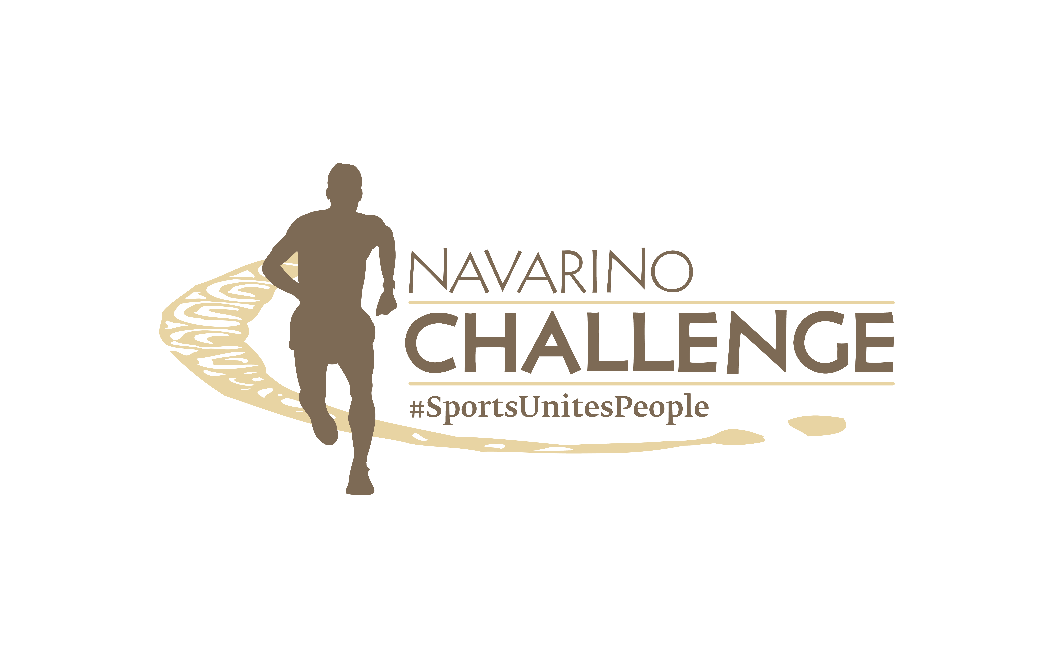

PRESS RELEASE

Registrations Open for Navarino Challenge 2024

Recognized once again as the best sports tourism event
in Greece with 22 awards

Athens, May 28, 2024 – The sports tourism and wellness event Navarino Challenge returns for its 12th year, from October 18-20, 2024, at Costa Navarino and Pylos. With the global message “sports unites people” the event will once again bring people of all ages and abilities, amateurs and professionals together with Olympians and world champions. The three-day schedule will include more than 55 activities held at two of the destination’s four hotels, W Costa Navarino and The Westin Resort Costa Navarino.

Gymnastics with Petrounias, Millousi, Hatziefstathiou, Tantalidis
The event’s schedule includes the Olympic sport of gymnastics. Specifically, gymnastics lessons for adults will be held by the Olympic gold and bronze medalist on rings Lefteris Petrounias, the 3-time Olympian Vasiliki Millousi, and the gymnastics champions Georgios Hatziefstathiou and Antonis Tantalidis, with the support of Gymnastics Stars. Similarly, gymnastics classes for children will be conducted by Lefteris Petrounias and Vasiliki Millousi, with the support of Gymnastics Stars.

Football Clinics with the European Champion Kostas Katsouranis
For the first time, Navarino Challenge will welcome the European Champion with the Greek national team at Euro 2004, Kostas Katsouranis. The former international midfielder, with appearances at top Greek and European clubs like Benfica, will be this year’s guest of honor. Additionally, Football Clinics for children 5 to 17 years old will be held under his supervision and supported by the Falcons Football Academy.

Watch the video with some highlights from last year’s Navarino Challenge here: https://youtu.be/DyhHefdDF_8?si=AeONvqEbvQkXDRCd

Running at the magical Voidokilia
Running has been a staple of Navarino Challenge since its inception. Participants can run in one of Greece’s top Half Marathons, the Navarino Challenge Half Marathon by The North Face, alongside the Greek-American ambassador of Greek tourism and ultramarathoner Constantine “Dean” Karnazes. Famous for its unique shape resembling the Greek letter omega (Ω) and recognized as one of the world’s most beautiful beaches, Voidokilia Beach is an ideal running destination. It is the only trail run in Greece that combines soil, sand, and asphalt. Runners can opt for the enchanting 10km route along the sea or the 5km route powered by Miele, winding through centuries-old olive trees, which is also suitable for dynamic walking. On the same day, a 1km route will be held for young people aged 10 to 14 and a 1km route for children up to 9 years old.

Register for the Running Activities
Participants can join the 21.1km, 10km, 5km, and 1km races immediately. The children’s race is free of charge. Register through the special form available at the following link.

Miele celebrates 125 years of quality
Miele, the world’s leading manufacturer of premium domestic appliances, celebrates its 125th anniversary and participates as a Platinum Sponsor in Navarino Challenge 2024. This year’s event promises many surprises and activities for the public. Among them, participants can attend the Stratos Drakoulis Masterclass powered by Miele. For the first time, Navarino Challenge participants will enjoy unique cuts of Kobe Beef and Wagyu prepared with Miele’s premium appliances. Participation requires booking your stay at Costa Navarino through Navarino Challenge. All proceeds from the Masterclass will support 12 non-profit organizations through the “Sharing Is Caring” charitable initiative. Register through the special form available at the following link.

Book your accommodation package now
Enjoy a weekend filled with outdoor sports activities for all ages. Book now the complete sports activities package and experience a unique sports and cultural event. For more information on accommodation packages at W Costa Navarino and The Westin Resort Costa Navarino please email booking(at)navarinochallenge.com or call Vita N Travel at +30 210 3249070. Check the accommodation packages here.

The event’s schedule includes more than 55 activities held at W Costa Navarino and The Westin Resort Costa Navarino.
This year’s activities include besides running, football lessons, watersports, tennis (tournament and lessons), padel tournament, cooking masterclass, pickleball, spinning, group cycling, sunset party, basketball lessons & 4on4 tournaments, beach volleyball tournaments, beachathlon, pilates, climbing, bike ride in Voidokilia, golf, taekwondo, crossfit, yoga, kayaking to Sphacteria, high-intensity training, baby swimming, skateboarding, and more to be announced in the coming weeks.

At the top with 22 more awards
The event was distinguished at the Tourism Awards 2024 with 3 awards. Since 2014, Navarino Challenge has remained at the top of this institution, being recognized as the best sports tourism event. Specifically, the event received 3 Gold Awards in the categories:
- Sports Events
- Health & Wellness
- Sports & Adventure Stay Experience
In addition, the event won 19 awards at the Sports Marketing Awards 2024 and was recognized as the event with the most awards. Navarino Challenge received 1 Platinum, 11 Gold, 5 Silver, and 2 Bronze awards such as:
- Best sports/cultural tourism event with the highest score in the entire section, resulting in a Platinum distinction
- Best CSR program with “sharing is caring”
- Best fan engagement program
- Best sports event photography
- Best strategy for branding
- Best strategy for sales
- Most innovative use of content creators & influencers
- Best Multi-Sport Event
- Best event for kids
- Best extreme/alternative/fight sports event
- Best summer sports event
The event also received distinctions for its successful sponsorship collaborations with Miele Hellas and the MOTODYNAMICS Group with the SIXT brand.

Miele is the Platinum Sponsor.
MOTODYNAMICS Group is the Gold Sponsor.
Costa Navarino, W Costa Navarino, and The Westin Resort Costa Navarino are the Official Hospitality Sponsors.
Knorr, and The North Face are the Silver Sponsors.
Vikos Natural Mineral Water is the Official Water.
Luanvi is the Official Sports Equipment Supplier.
Trace ‘n Chase and Pilia Express are the Bronze Sponsors.
SIXT, a member of the MOTODYNAMICS Group is the event’s Premium Mobility Partner.
Navarino Icons, a series of authentic agricultural products from Messinia inspired by the rich traditions and history of the region, is the event’s Authentic Flavor Partner promoting the Greek Mediterranean diet known for its health benefits.
Messinian Nest, Poseidonia Restaurant, Karalis Beach Hotel, Karalis City Hotel & Spa, and the Municipality of Pylos-Nestor are the event’s Partners.
Kois Optics are the Official Optics Partner.
Phee, and Messinian Spa are the Supporters.
p³ = Plastic Pollution Prevention is the Sustainability Partner.
Athens University of Economics and Business, which recently signed a Memorandum of Cooperation with the MOTODYNAMICS Group is the event’s Educational Partner, aiming to strengthen the relationship between business and academic communities, connect students and graduates with the job market, as well as enhance research and sustainability actions.
Angelic Yoga Arts, Falcons Football Academy, FitnessArt, Moraitis Watersports, Mouratoglou Tennis Center Costa Navarino, Navarino Golf Academy, Navarino Outdoors, Pilates by Mandy, Red Swim Academy, Swim O’ Clock, Triantafyllidis Beach Arena are the Athletic Partners.
The event is Assisted by Vita N Travel, Pylos Association of Enterprises for Tourism Development.

Navarino Challenge will be held under the auspices of the Ministry of Tourism and the Greek National Tourism Organization.
The event is organized by ActiveMedia Group, which is also responsible for the event’s Sports Production.

More information about this year’s activities and schedule will be announced in the coming weeks.

#navarinochallenge #costanavarino #sportsunitespeople #eatwell #runwell #livewell

Website: www.navarinochallenge.com
Facebook: www.facebook.com/Navarinochallenge
Instagram: http://instagram.com/navarinochallenge
Twitter: https://twitter.com/NavarinoC
YouTube: http://www.youtube.com/user/NavarinoChallenge
TikTok: https://www.tiktok.com/@navarino_challenge

