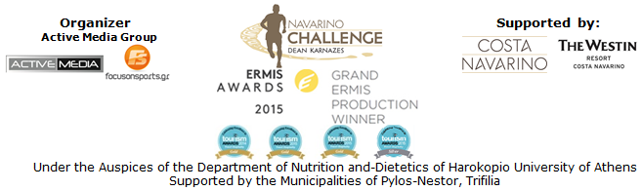

PRESS RELEASE

The “Navarino Challenge 2016” event’s schedule!

Dance lessons and a cooking event to further enrich this year’s schedule!

Athens, July 22 2016 – Days count down for the celebration of the top sports tourism event and the time has come for anyone to decide upon the activities to enroll for during the weekend of “Navarino Challenge”, on September 9-11, 2016.

This year’s event’s schedule is as rich as it gets, with 18 non-competitive activities addressed to all family, highlighting the values of exercise and nutrition and raising awareness on childhood obesity, a serious medical condition affecting a child’s health or well being. The schedule also includes activities such as running, swimming and SUP for everyone, while participants will have the chance to watch a demonstration race with Optimist and Laser boats in Pylos port!
For those staying at The Westin Resort Costa Navarino additional activities like taekwondo, climbing, pilates, bike ride, boccia, basketball, golf, kick boxing, baby swimming, aqua aerobic, kids’ athletics, scuba diving, dance lessons and a cooking event full of surprises, are offered. The detailed schedule and timetable of all activities is included in the following link: http://navarinochallenge.com/event_schedule_2016.html

Food and its process, namely the Mediterranean diet has always been an important element in Greece's culture. Potteries found in the palace of King Nestor, dating from 1300 BC testify that visitors or foreigners seeking for asylum in Pylos were offered meat processed with a specific technique. Both Messinian hospitality and Mediterranean diet will be highlighted through various activities supported by the Peloponnese food blogger Gogo Papadionysiou also known as Mamatsita!
On Saturday September 10, during the swimming day, local women will make traditional lalagia & diples with the care of Mamatsita, in Pylos. Respectively, on Sunday September 11, the famous food blogger will be supporting the participants in running, by offering them traditional sweets and products in Costa Navarino. The two cooking challenges will be supported by the team of Poseidonia Restaurant.

Navarino Icons, a range of products from Messinia inspired by the rich traditions and heritage of the area will be the official supporter of the event for one more year. All products are produced in small quantities by local producers and artists meeting qualitative and creative criteria, while raw materials are drawn from the estates, the olive groves and the botanical gardens of Costa Navarino.

Dance, for the first time this year, will be at the foreground!
The artistic and athletic expression referring to the movement of the body following the rhythm of the music will be represented by Nick Marianos, choreographer of stars and Creative Director and Owner of Nick Marianos Dance Factory. Nick Marianos and his team will teach dance lessons which include the following styles: video clip dance, all hip-hop styles, break dance and hip-hop choreographies.

Apart from the extra activities offered, “Navarino Challenge” has also secured for those participants who will be staying at The Westin Resort Costa Navarino, some very exclusive extra benefits offered by the brands supporting the event.
Precisely, Anazoe Spa, which took its name from the Greek word for rejuvenation will offer a 20% discount on treatments based on ancient Greek beauty practices. Those interested can take advantage of the offer during their participation in “Navarino Challenge”, by booking their appointment via email at anazoe@costanavarino.com.
In addition, Inbi, the Japanese fusion restaurant at Costa Navarino will offer a unique experience to the “Navarino Challenge” guests with exceptional tastes of unsurpassed quality.
You may find more information about the offers which are valid during your stay at “Navarino Challenge” at the following link: http://navarinochallenge.com/event_offers_2016.html

Book your room now at The Westin Resort Costa Navarino and take advantage of the privileged prices available for those wishing to enjoy the full schedule of “Navarino Challenge. For further information please contact the event’s official travel agent Vita N Travel. Telephone: +30 210 3249070 or visit: http://navarinochallenge.com/event_accommodation_in_2016_en.html

Registrations are open and anyone can take part in activities of running, swimming and SUP by filling the special form available at the following link:
http://activemedia.com.gr/product/navarino-challenge/

The event will be held for one more year, under the Auspices of the Department of Nutrition and-Dietetics of Harokopio University of Athens with the support of Costa Navarino and The Westin Resort Costa Navarino, as well as the Municipalities of Pylos-Nestor and Trifilia.

For more information about the event, you may contact us through the following special form: http://www.navarinochallenge.com/contact.html

Official Sponsors: Allianz Greece, “Vikos” Natural Mineral Water
Official Airline Partner: Qatar Airways
Official Supporters: BIC®, BIC® Sport, Navarino Icons, Village Cinemas
Assisted by: Health Runners Club of Messinia, Pylos Association of Enterprises for Tourism Development, Maritime Athletic Pylos Association “Nestor”, Explore Messinia, Navarino Outdoors, Swim Academy, Aqua Divers Club, Scuba Hellas, Navarino Golf Academy, Restaurant Posidonia Restaurant ThaMa, Alpha (Athlima SA), Department of Sports Organization & Management from University of Peloponnese, Anazoe Spa Costa Navarino, 1morekm, Hellenic Athletics Federation (SEGAS), IAAF Kids Athletics, Apia, Inbi, Diana “exoplizein”
Official Travel Agent: Vita N Travel
Official Broadcaster: OTE TV
TV Communication Partner: National Geographic Channel

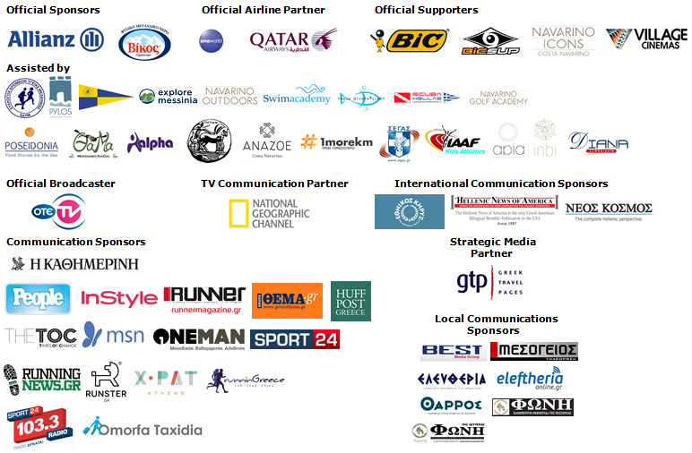

Website: www.navarinochallenge.com
Facebook Page: www.facebook.com/Navarinochallenge
Facebook Event: https://www.facebook.com/events/1575864132703599/
Twitter Account: https://twitter.com/NavarinoC
YouTube Channel: http://www.youtube.com/user/NavarinoChallenge
Google + Account: https://plus.google.com/115165548850159469774/posts
Instagram Page: http://instagram.com/navarinochallenge
Hashtags: #navarinochallenge #costanavarino #eatwell #runwell #livewell

Costa Navarino:
Costa Navarino is the prime, sustainable destination in the Mediterranean, located in the Greek region of Messinia in the southwest Peloponnese. One of the most unspoiled and breathtaking seaside Mediterranean landscapes, this area has been shaped by 4,500 years of history. Its philosophy is driven by a genuine desire to promote Messinia, while protecting and preserving its natural beauty and heritage. It will comprise a number of distinct sites featuring 5-star deluxe hotels, luxury residences, conference facilities, spa and thalassotherapy centres, signature golf courses, as well as a wide range of unique year-round activities for adults and children. Navarino Dunes, the first area, is home to two luxury 5-star hotels, The Romanos, a Luxury Collection Resort and The Westin Resort Costa Navarino; The Dunes Course – the first signature golf course in Greece- Anazoe Spa, a 4,000sq.m. spa & thalassotherapy centre; the state-of-the-art conference centre House of Events; specially designed facilities for children; as well as a variety of gastronomy venues, sports, outdoor and cultural activities. Navarino Bay, the second area is home to the signature golf course, The Bay Course.
High resolution photos can be accessed through the following link, by using the password nestor.

About The Westin Resort Costa Navarino:
The Westin Resort Costa Navarino is one of the two luxury 5-star properties at Navarino Dunes, the first resort area in Costa Navarino, the prime destination in the Mediterranean. Overlooking the Ionian Sea coastline of the Dunes Beach, The Westin Resort Costa Navarino 445 rooms and suites, inspired by old Messinian mansions, spring from nature and create an ambiance of genuine hospitality. Voted as the “Best Family Destination” in the Mediterranean amongst Europe’s Starwood Hotels & Resorts, The Westin Resort Costa Navarino is the ideal destination for family getaways as it proposes a plethora of children activities such as a wonderful aqua park with water slides, playground and recreational center as well as two specially designed hubs for children, Cocoon and SandCastle. At Navarino Dunes there is also The Romanos, a Luxury Collection Resort, the 18-hole signature golf course The Dunes Course the 4,000 sq.m Anazoe Spa, a state-of-the-art conference center, as well as a variety of culinary venues, sports, outdoor and cultural activities. Navarino Bay, the second area in Costa Navarino, features the second 18-hole signature golf course, The Bay Course. For more information on The Westin Resort Costa Navarino, please visit www.westincostanavarino.com, or follow us on Twitter.

